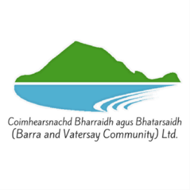
Coimhearsnachd Bharraidh agus Bhatarsaidh
(Barra & Vatersay Community Limited)
Membership Application Form
Become a member of Barra & Vatersay Community Limited and participate in the future development of Barra & Vatersay.
- Full membership of Barra & Vatersay Community Limited is open to all individuals and organisations who are interested in or already involved in the following:
- Engaging in the economic, environmental and social regeneration of our community.
- Community-based and not for private profit.
- Actively involved in partnership between the community, voluntary, private and public sectors.
Individual Membership: Cost £1.00
Is open to all residents of Barra and Vatersay over 18 who are registered on the electoral roll.
Community Groups Membership: Cost £5.00
Is open to any formally constituted community groups based on Barra and Vatersay whose membership is open to the whole community.
I wish to apply for membership of Barra and Vatersay Community Limited. I understand that Barra and Vatersay Community Limited is a company limited by guarantee. Please complete using block capitals.
Name………………………………………………………………………………………………………
Organisation Name (if applicable)……………………………………………………………….
Mobile………………………………………… Home Tele…………………………………………….
Email………………………………………………………………………………………………………….
I enclose cash/cheque made payable to Barra and Vatersay Community Limited.
Bank Transfer: Barra & Vatersay Community Ltd, Royal Bank of Scotland
Account No: 00135575 Sort Code: 83-17-03.
Please tick the type of membership: Individual:  Corporate:
Signature……………………………………………. Date…………………
☐ I agree to receive email membership communications about event announcements, project updates, job opportunities and company news. I understand that I can withdraw my consent at any time by clicking unsubscribe.
Please complete using block capitals and return to Barra & Vatersay Community Ltd, Castlebay Hall, Isle of Barra, HS9 SXD or email to marina@barra-vatersay.org.uk

